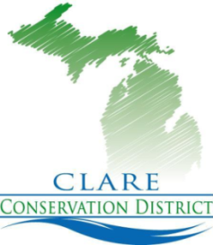

CLARE CONSERVATION DISTRICT

Offices of Clare County Soil Erosion,

Michigan Forestry Assistance Program,

Clare County Gypsy Moth Suppression Program
225 WEST MAIN STREET Telephone: (989) 539-6401
P.O. BOX 356 Fax: (989) 539-2182
HARRISON, MI 48625-0356 Web Site: www.clarecd.org

Helpful Tips to Help Control Gypsy Moth Populations in Clare County
Clare County is surveyed annually in the fall by the Clare County Conservation Gypsy Moth Suppression Teams.
Over the last few years, an increase of egg masses have been detected in areas of Clare County. These area includes residential areas.
The majority of the egg masses have been located on homes, garages, sheds, overhangs, electrical boxes, wishing wells, kids play scapes, foundations, and wood piles. These locations may be seasonal and vacant homes. The homes usually have wooden exteriors and shady sides of the buildings.
The egg masses are anywhere from the size of a dime to as large as a silver dollar and larger. The egg masses have anywhere from 500 to 10,000 eggs depending on the size.
The egg masses are a beige color and feel velvety. Around the egg masses, pupae is usually detected and that is the shell from which the gypsy moth caterpillar becomes a moth in the fall. In 2017, the moths hatched in late July, early August.
The female gypsy moth is white with flecks of black and has a goldish spot on her head and does not fly. The male has a brown hue. After mating occurs, the moths die.
There is a specific way to remove the egg masses prevent the population from increasing the following year.
- The easiest way to remove the egg mass/masses is using a putty knife, playing card, or business card.
- Carefully go behind the egg masses and “PEEL” it off into a dish of “SOAPY” water or paper bag.
- Any eggs that fall to the ground will hatch next year. Winter does not kill the eggs so care should be taken when removing.
- The dish soap container will kill the eggs and burning the egg masses is also a great alternative.
- Remove all the pupae at the same time.
For a detailed look at the gypsy moth, you can also go to clarecd.org or visit the office. For $6.36 you can purchase a gypsy moth trap in the district office. These environmentally friendly traps attract the male gypsy moth and prevents the moths from reproducing.

