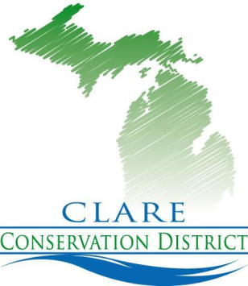

CLARE CONSERVATION DISTRICT

Offices of Clare County Soil Erosion,

Michigan Forestry Assistance Program,

Clare County Gypsy Moth Suppression Program

225 WEST MAIN STREET Telephone: (989) 539-6401
P.O. BOX 356 Fax: (989) 539-2182
HARRISON, MI 48625-0356 Web Site: www.clarecd.org

Board of Directors:

Larry Gross, Chairman

John Hood, Vice-Chairman

Scott Peterson, Member

John Kennedy, Member

Roberta Schunk, Treasurer

District Staff:

Administrator –
Melissa Townsend

Soil Erosion Agent/
Gypsy Moth Suppression Coordinator –
Renee Davis

Forester –
Nia Becker

NRCS Staff:

District Conservationist –
David Lehnert

Field Technician –
DeAnn Denton

Effective immediately, Part 91, Soil Erosion and Sedimentation Control, of the NREPA, 1994 PA 451, as amended, requires each designated agent applying for a Soil Erosion permit on behalf of another person to include a statement authorizing him/her to secure the permit. Please have the landowner complete this Letter of Authorization to be submitted with the application.

Letter of Authorization

________________________________is authorized to secure a Soil Erosion Permit in my name for a project requiring said permit at:
________________________________________ (address)
________________________________________ (landowner signature)

_______________________ (date)

